** **



**ARIGNAR ANNA GOVERNMENT ARTS COLLEGE- VILLUPURAM.**

**UG & RESEARCH DEPARTMENT OF STATISTICS**

**NAAN MUDHALVAN PROJECT**

**III B.SC.STATISTICS**

**SHIFT- 1**

|  |
| --- |
| **PROPERTY MANAGEMENT APPLICATIONS USING SALESFORCE** |
| NEETHIVELAN A - E/M |

**TEAM LEADER : NEETHIVELAN A**

**TEAM MEMBER:**

1. **MUGESH V**
2. **MURUGAN P**
3. **MURALI N**

**Property Management Application using Salesforce**

**Team lead- A. NEETHIVELAN**

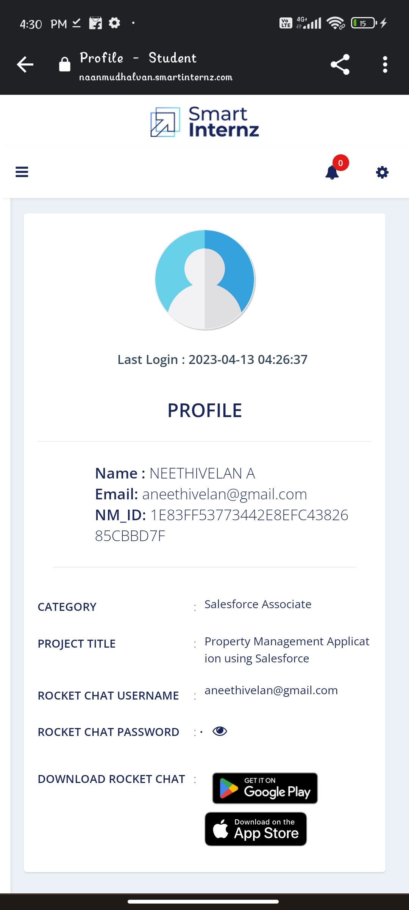

**Team Member 1- V. MUGESH**

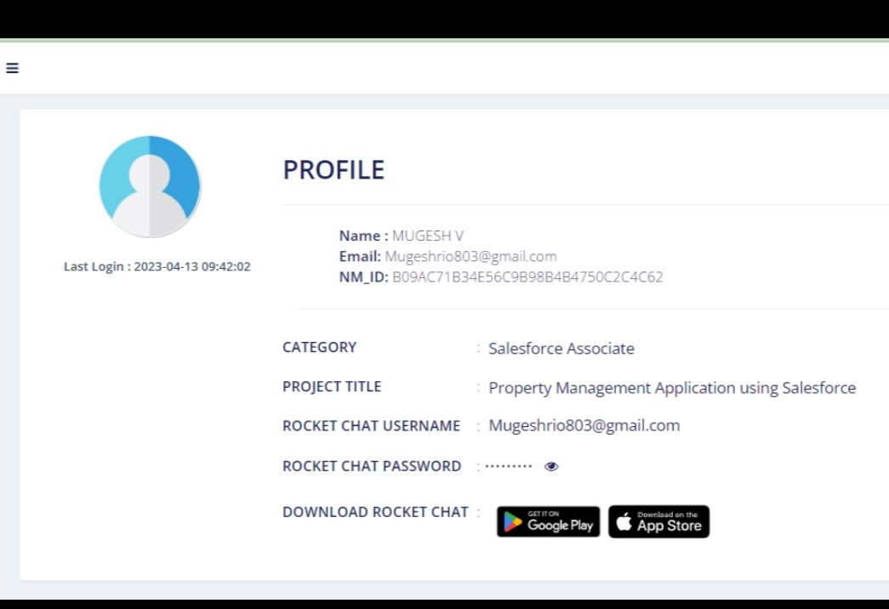

**Team Member 2-N. MURALI**

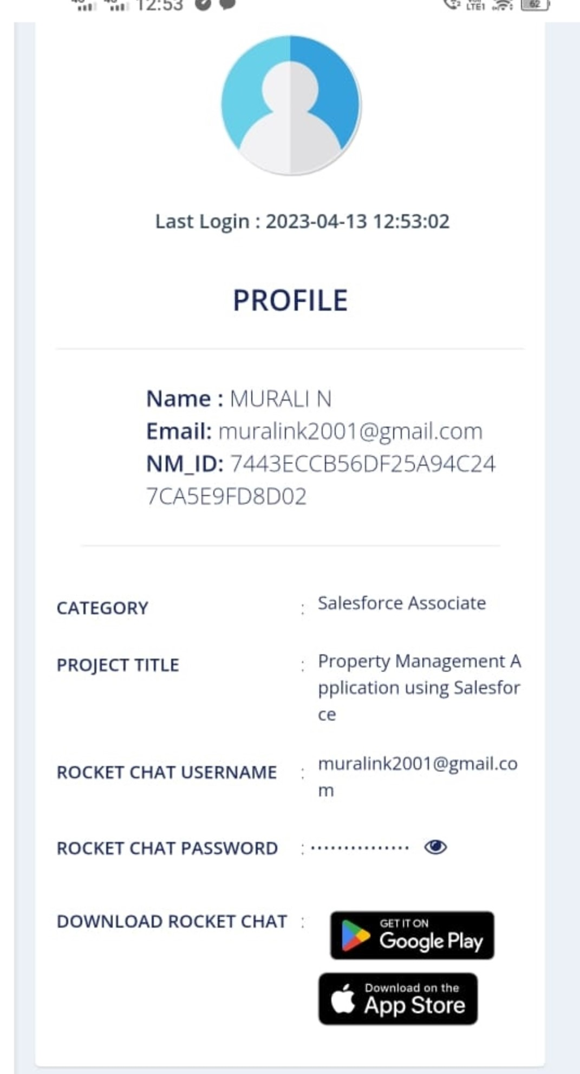

**Team Member 3- P. MURUGAN**

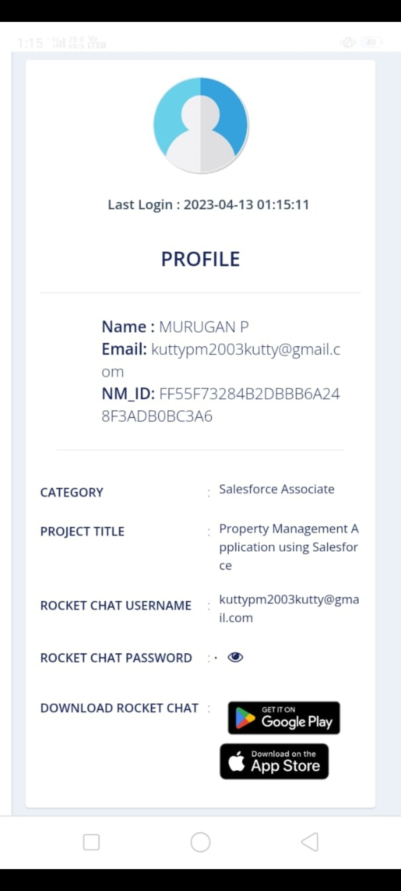

**Property Management Application using Salesforce**

**1 INTRODUCTION**

* 1. **Overview:** Salesforce unites your marketing, sales, commerce, service, and IT teams from anywhere with Customer 360 — one integrated CRM platform that powers our entire suite of connected apps. With Customer 360, you can focus your employees on what’s important right now: stabilising your business, reopening, and getting back to delivering exceptional customer experiences.
  2. **Purpose:** Salesforce is a [Customer Relationship Management](https://www.educba.com/customer-relationship-management-tools/) (CRM) product which was [developed by a Software Development](https://www.educba.com/software-development-vs-web-development/) Company named Salesforce Inc., an [American Cloud Computing company](https://www.educba.com/cloud-computing-companies/) where its headquarters is based in San Francisco, California, USA. It was a publicly listed company in the USA and also listed under NYSE (New York Stock Exchange). It was founded by Mark Benioff and Parker Harris. It was founded in the year 1999. It is mainly focused on the purpose of Customer Relationship management applications. Its products are such as Platform Applications, [Sales](https://www.educba.com/sales-vs-marketing/) Cloud and Service Cloud Application products, Marketing Cloud, Community Cloud, and Commerce Cloud Applications.

1. **Problem definition Design Thinking**
   1. **Empathy**

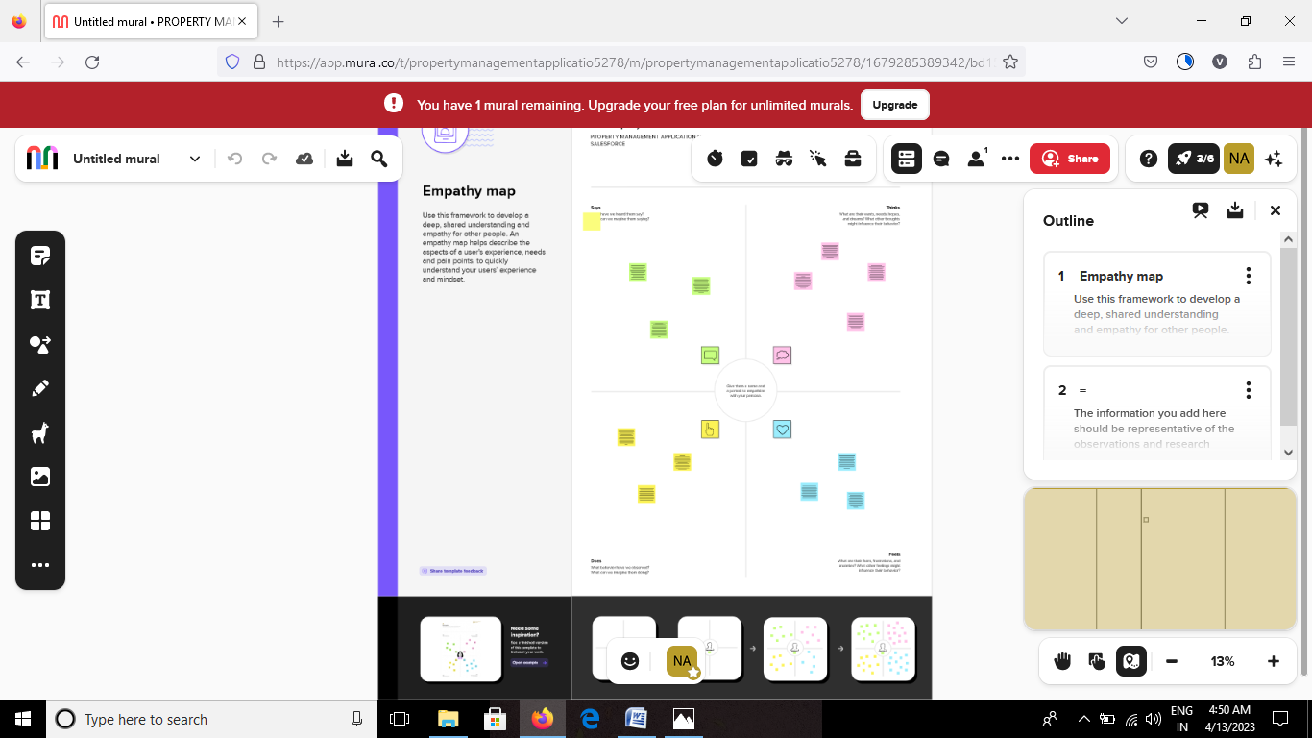

**2.2 Ideation and Brainstorming Map**

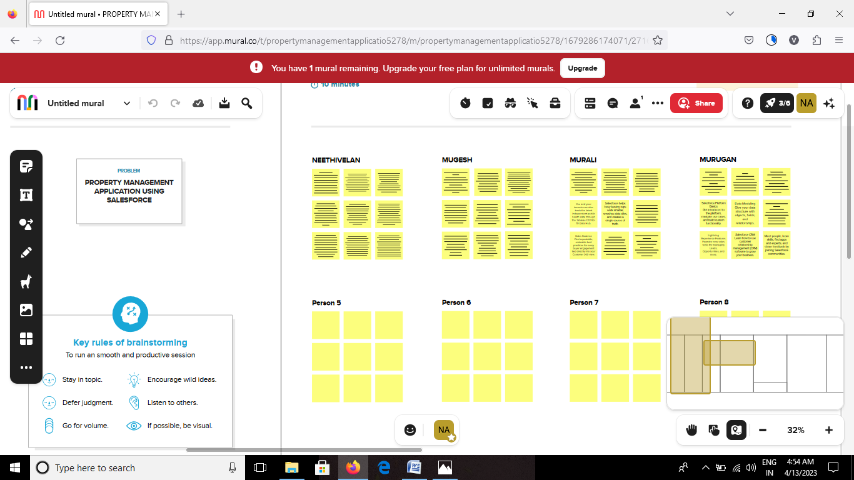

1. **RESULT**

**3.2 Activity & screenshot**

**Milestone 1**

**Salesforce: what is salesforce? Salesforce is your customer success platform, designed to help you sell, service, market, analyze, and connect with your customers.**

**Activity1:**

**Creating a salesforce developer Org: A developer org has all the features and licenses you need to get started with salesforce.**

**Object**

**What is an object?**

**Salesforce objects are database tables that permit you to store data that is specific to an organisation. It consists of fields (columns) and records (rows).**

**Salesforce objects are of two types:**

1. Standard Objects: Standard objects are the kind of objects that are provided by salesforce.com such as users, contracts, reports, dashboards, etc.

2. Custom Objects: Custom objects are those objects that are created by users. They supply information that is unique and essential to their organization. They are the heart of any application and provide a structure for sharing data.

**To Navigate to Setup page**

1. Click on gear icon then click setup.

**To create an object:**

2. From the setup page then Click on Object Manager then Click on Create then Click on Custom

Object.

**On Custom object defining page:**

3. Enter the label name, plural label name, click on Allow reports, Allow search then Save

**Create Object Buy**

1. To create an object:

2. From the setup page then Click on Object Manager then Click on Create then Click on Custom Object.

3. Enter the label name then Buy

4. plural label name then Buyers

5. click on Allow reports,

6. Allow search then Save

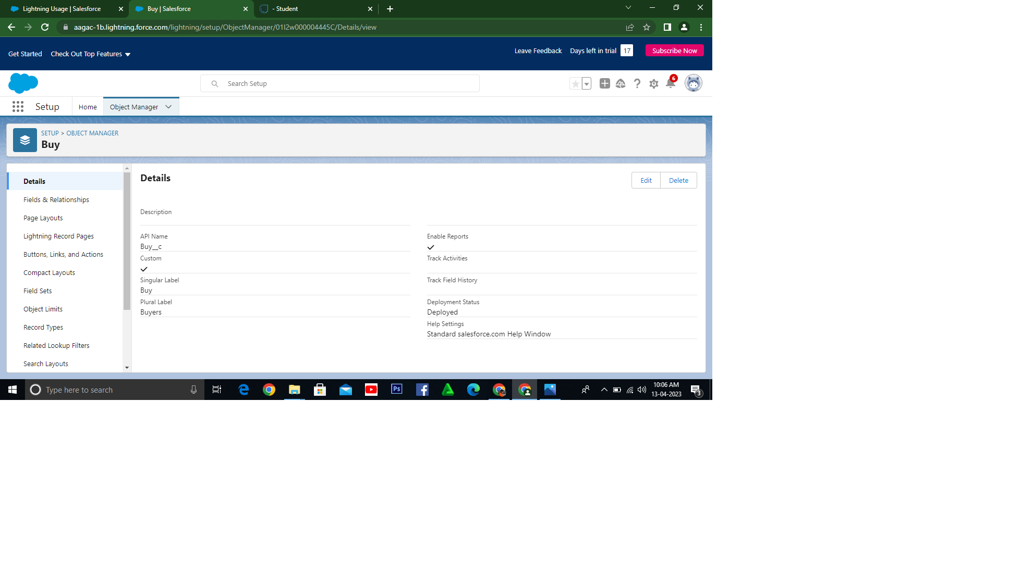

**Create Object Rent**

1. To create an object:

2. From the setup page then Click on Object Manager then Click on Create then Click on Custom Object.

3. Enter the label name then Rent

4. plural label name then Rents

5. click on Allow reports,

6. Allow search then Save

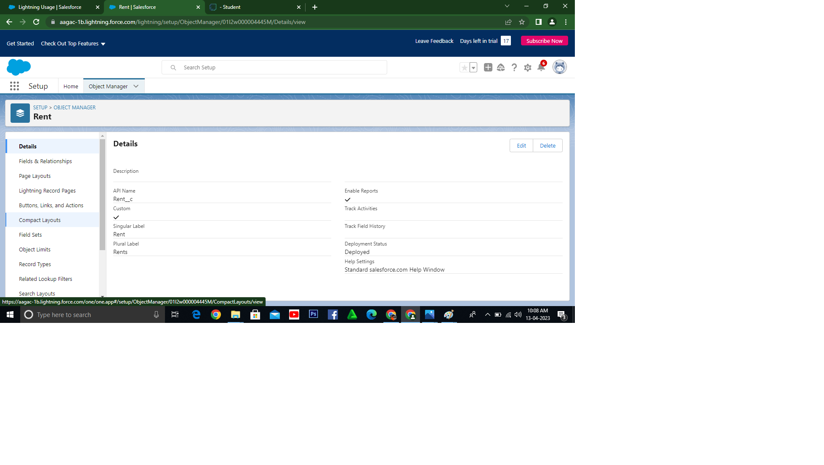**Create Object Loan**

1. To create an object:

2. From the setup page then Click on Object Manager then Click on Create then Click on Custom Object.

3. Enter the label name then Loan

4. plural label name then Loans

5. click on Allow reports,

6. Allow search then Save

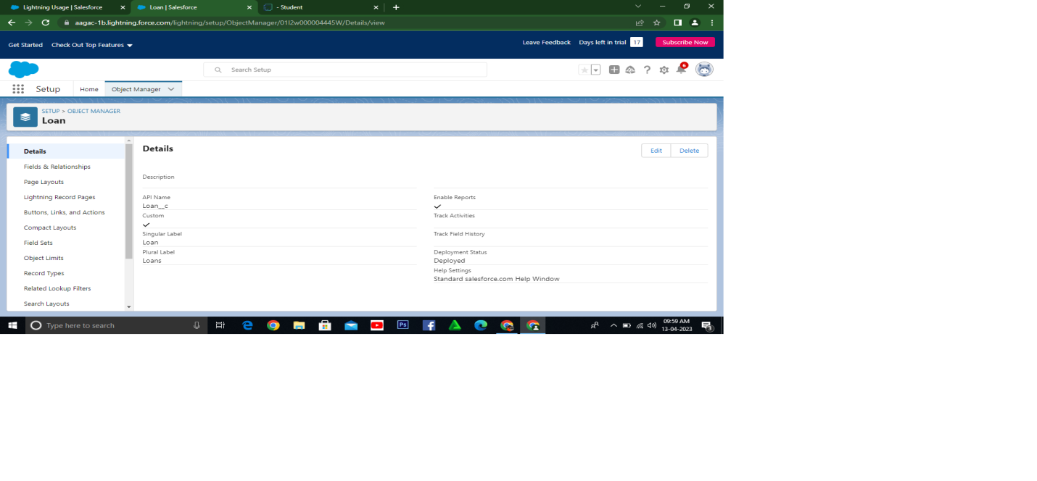

**Tab**

**What is Tab?**

A tab is like a user interface that is used to build records for objects and to view the records in

the objects.

**Types of Tab**

1. Custom object tab

2. Web tab

3. Visualforce tab

**Create the Lightning Tab**

To create a Tab:(Lead)

1. Go to setup page then type Tabs in Quick Find bar then click on tabs then New (under custom

object tab)

2. Select Object(Lead) then Select the tab style then Next (Add to profiles page) keep it as

default then Next (Add to Custom App) keep it as default then Save.

**To create a Tab:(Buy)**

To create a Tab:(Lead)

1. Go to setup page then type Tabs in Quick Find bar then click on tabs then New (under custom

object tab)

2. Select Object(Buy) then Select the tab style then Next (Add to profiles page) keep it as

default then Next (Add to Custom App) keep it as default then Save.

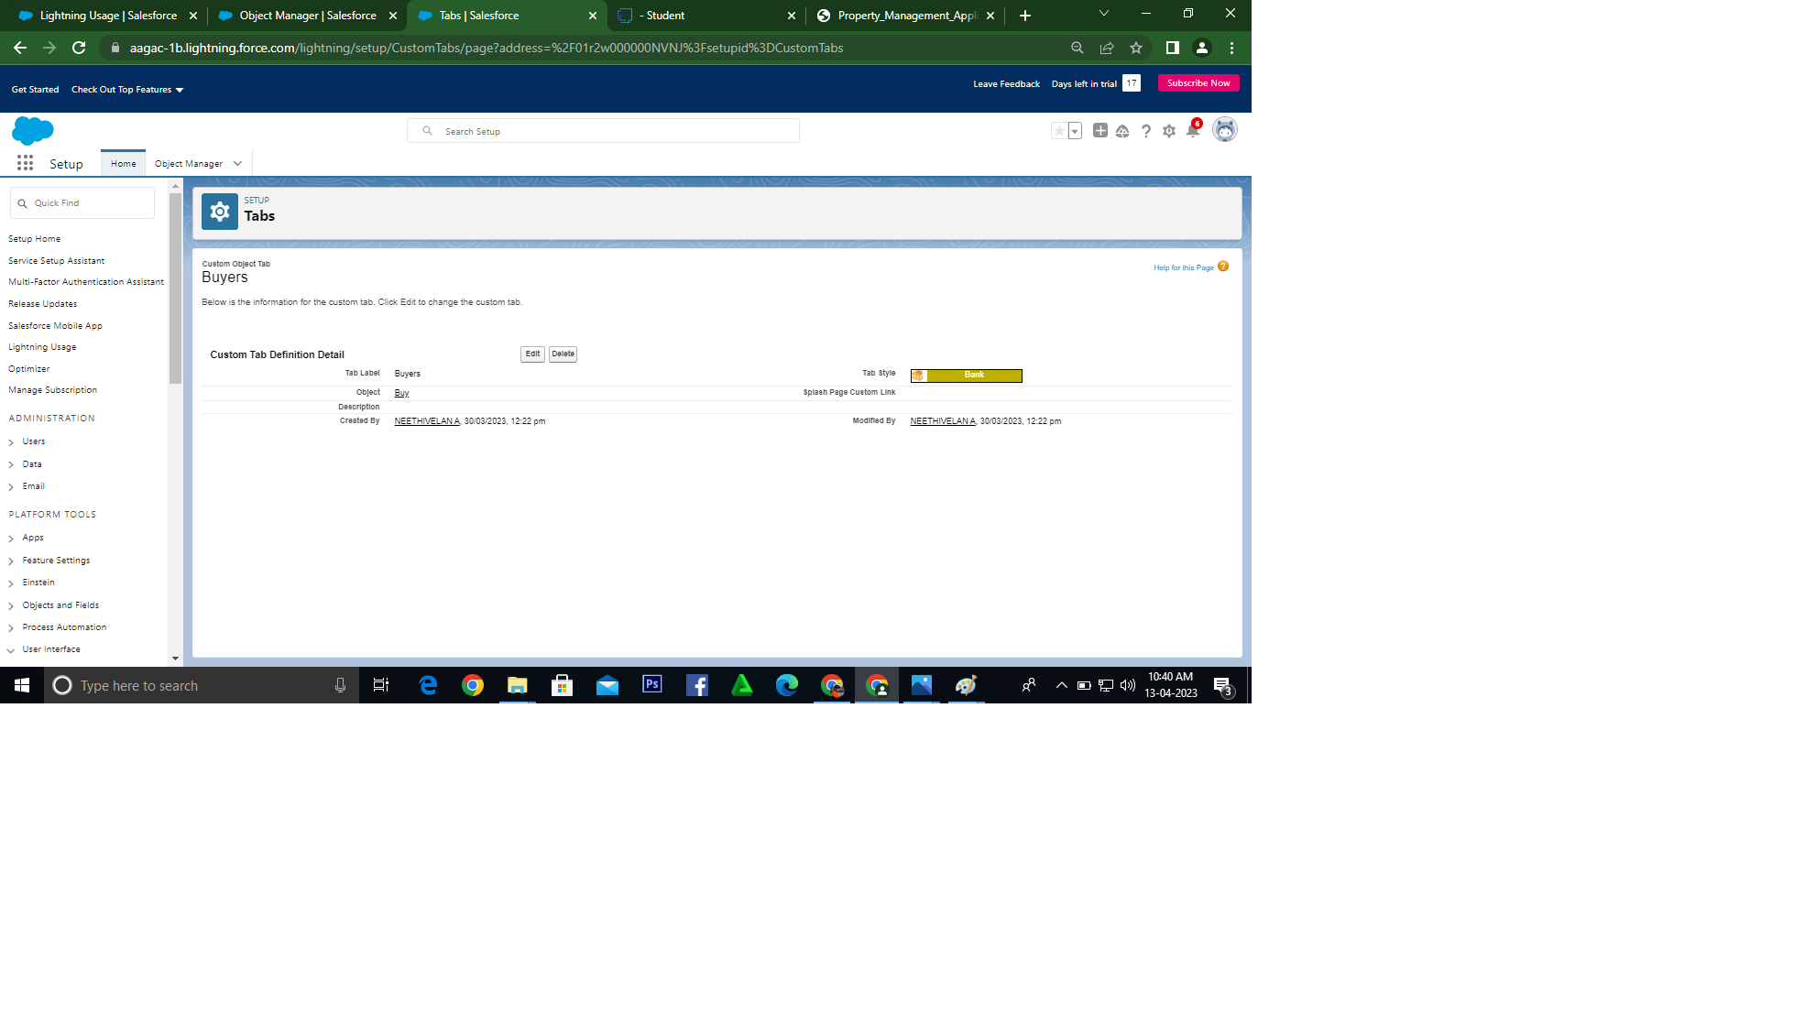

**To create a Tab:(Rent)**

1. Go to setup page then type Tabs in Quick Find bar then click on tabs then New (under custom

object tab)

2. Select Object(Rent) then Select the tab style then Next (Add to profiles page) keep it as

default then Next (Add to Custom App) keep it as default then Save.

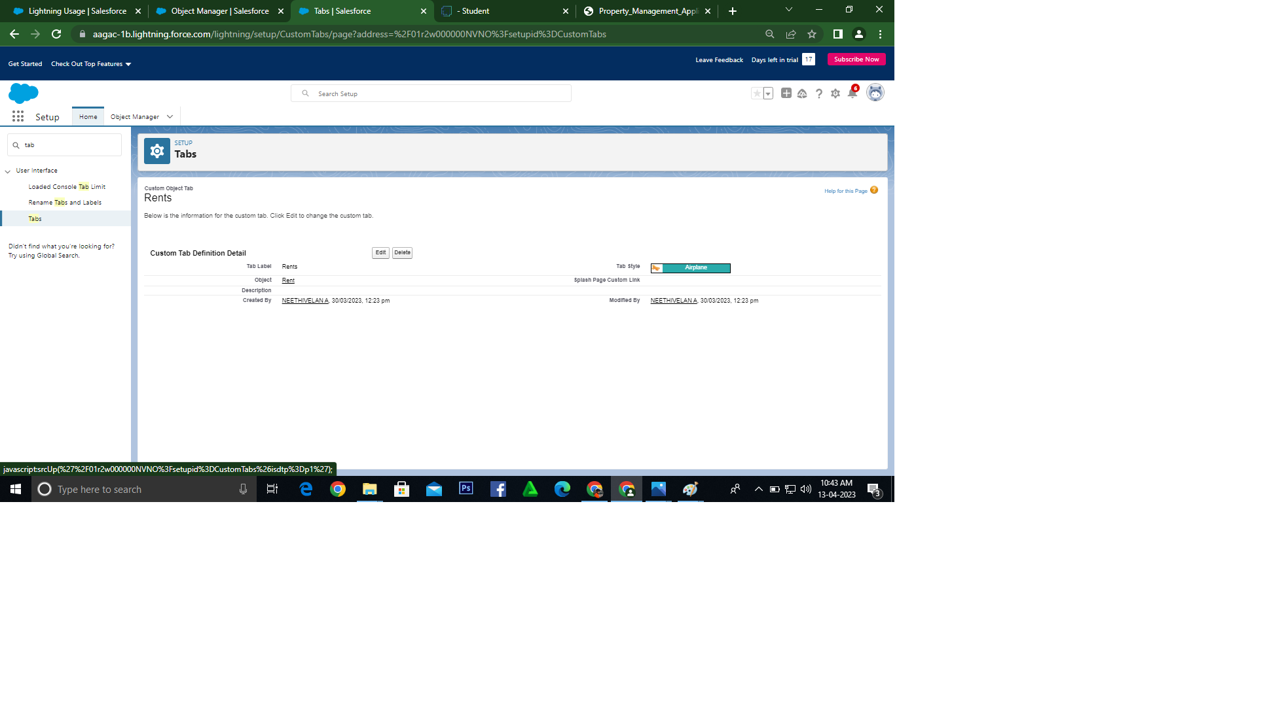

**To create a Tab:(Loan)**

1. Go to setup page then type Tabs in Quick Find bar then click on tabs then New (under custom

object tab)

2. Select Object(Loan) then Select the tab style then Next (Add to profiles page) keep it as

default then Next (Add to Custom App) keep it as default then Save.

**The Lightning App**

An app is a collection of items that work together to serve a particular function. In Lightning Experience, Lightning apps give your users access to sets of objects, tabs, and other items all in one convenient bundle in the navigation bar.

Lightning apps let you brand your apps with a custom color and logo. You can even include a utility bar and Lightning page tabs in your Lightning app. Members of your org can work more efficiently by easily switching between apps.

**Create the Lightning App**

1. Go to setup page then search “app manager” in quick find then select “app manager” then click on New lightning App.

2. Fill the app name as an Property Management in app details and branding then Next then (App option page) keep it as default then Next

3. (Utility Items) keep it as default then Next then(Add Navigation Items)(add tabs Lead, Buy, Rent, Loan) then Next then (Add User Profile) Add System Administrator, Salesforce platform user, Standard User then Next.

4. To Add Navigation Items:

Select the items from the search bar and move it using the arrow button then Next.

5. To Add User Profiles:

Search profiles in search bar then click on the arrow button then save & finish.

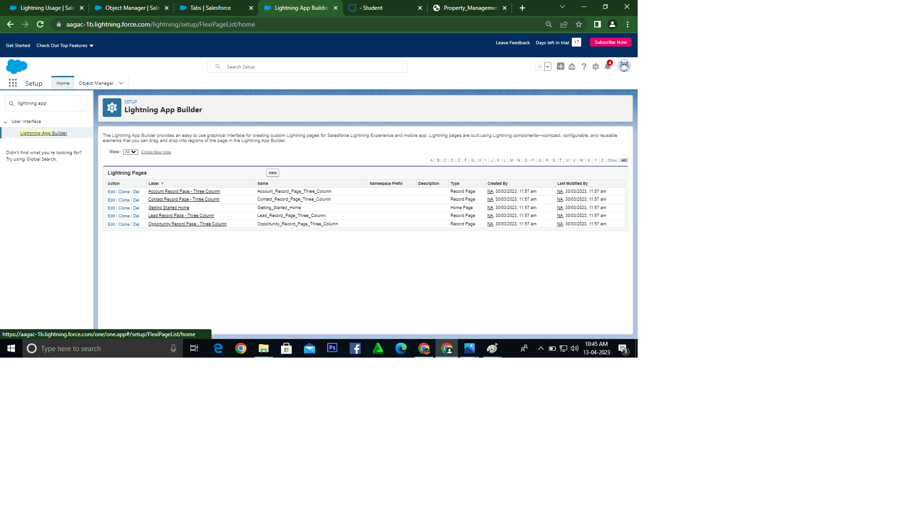

**Fields**

As the name suggests, the Standard Fields are the predefined fields in Salesforce that perform a standard task. The main point is that you can’t simply delete a Standard Field until it is a non-required standard field. Otherwise, users have the option to delete them at any point from the application freely. Moreover, we have some fields that you will find common in every Salesforce application. They are,

1. Created By

2. Owner

3. Last Modified

4. Field Made During object Creation

**Custom Fields:**

On the other side of the coin, Custom Fields are highly flexible, and users can change them according to requirements. Moreover, each organizer or company can use them if necessary. It means you need not always include them in the records, unlike Standard fields. Hence, the final decision depends on the user, and he can add/remove Custom Fields of any given form.

**Create the Lead Field**

1. Go to setup then click on Object Manager then type object name in search bar then click on the

object

2. Now click on “Fields & Relationships ” then New.

3. Fill the field label name Lead then Next then Next then Save.

Create the remaining Fields:

Follow the Above Steps to create the Field just change the Labels for Below Fields

Lead:(AutoNumber Created Field while creating Object) then L-{0000}

State: Create the Picklist Field (Maharashtra, Gujarat, Rajasthan)(Field Dependency)

City:Create the Picklist(Mumbai, Pune, Nashik)(Field Dependency)

Email: Create the Email Select the Data Type As Email (Email)

Phone:Select the Field Data type as (Phone)

In the Fields and Relationship go to the Field Dependencies

**Create For Object Buy**

1. Create Field for Buy

2. Create Property Type: (Picklist) (Residential, Commercial, Industrial)

3. Discount:(Percentage As the Field Data Type)

4. State:Create the Picklist Field (Maharashtra, Gujarat, Rajasthan)(Field Dependency)

5. City:(Take Any City for Field Dependency)

6. Annual Amount To Be Paid

**Create Field for Rent**

1. Rent:(Auto Number while Creating the object)? R-{0000}

2. Rental City:Select the Text as the Field Data Name(Any City)

3. BHK type:(Picklist) (1BHK, 2BHK,3BHK)

**Create Field for Loan**

1. Loan Id: Auto generated Field Take it as Autonumber LN-{0000}

2. Interest Rate: (Select the Field Data Type As Currency)

3. Term:(Select the Field Data type as Number)

4. Annual Loan Field create the Number as the field data type

5. Total Loan Instalments:( Field create the Number as the field data type)

6. Loan Repayment( Field create the Number as the field data type)

7. Loan Amoun( Select the Field data type as Formula)

8. For the Loan Object? Go to the fields and Relationship and select the formula in field data type. In Formula option select Advanced Formula and write the following

formula

(Loan_Repayment__c * (((1+( Interest_rate__c /52))^ Term__c) -1))/((

Interest_rate__c /52)*((1+( Interest_rate__c /52))^ Term__c))

##Check the syntax below whether the formula syntax is correct or not

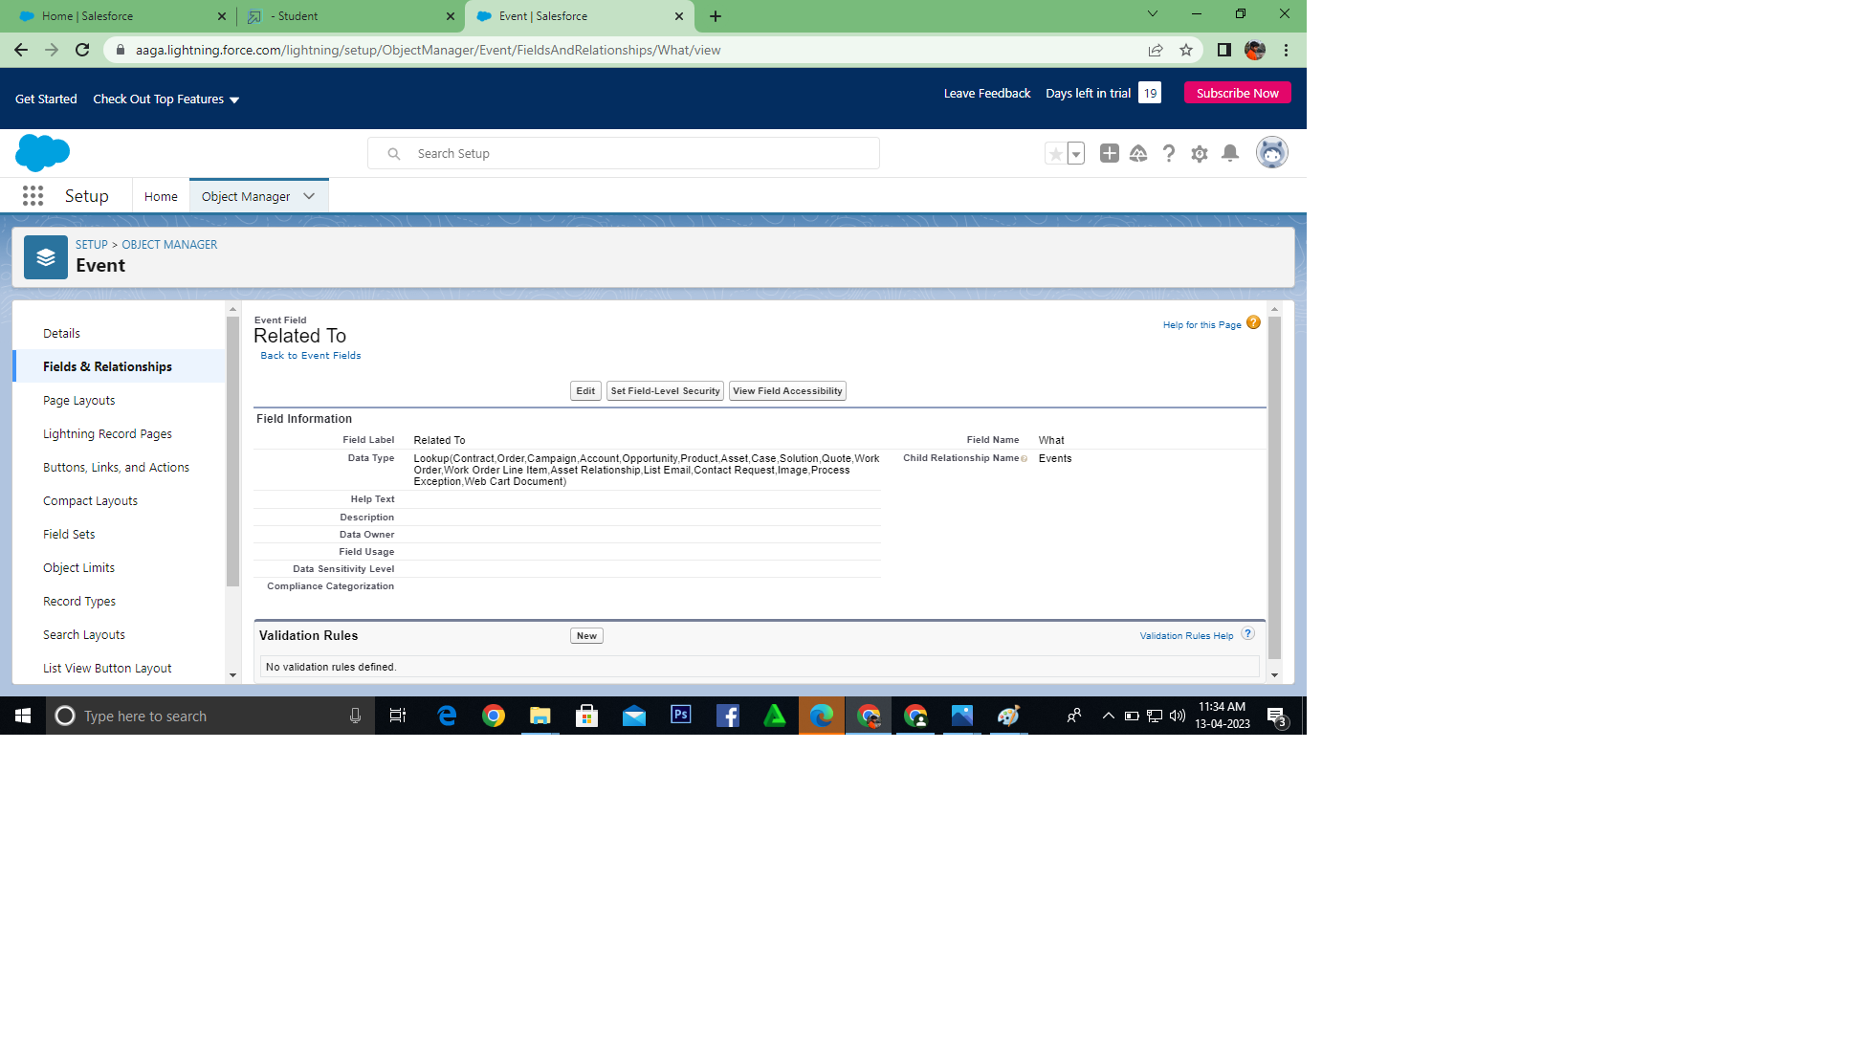

**Profile**

1. A profile is a group/collection of settings and permissions that define what a user can do in salesforce.

2. profile controls “Object permissions, Field permissions, User permissions, Tab settings, App settings, Apex class access, Visualforce page access, Page layouts, Record Types, Login hours & Login IP ranges.

3. You can define profiles by the user's job function. For example System Administrator, Developer, Sales Representative.

**Types of profiles in salesforce**

**A. Standard profiles:**

1. By default salesforce provide below standard profiles.

2. We cannot deleted standard ones

3. Each of these standard one includes a default set of permissions for all of the standard objects available on the platform.

**B. Custom Profiles:**

1. Custom ones defined by us.

2. They can be deleted if there are no users assigned with that particular one.

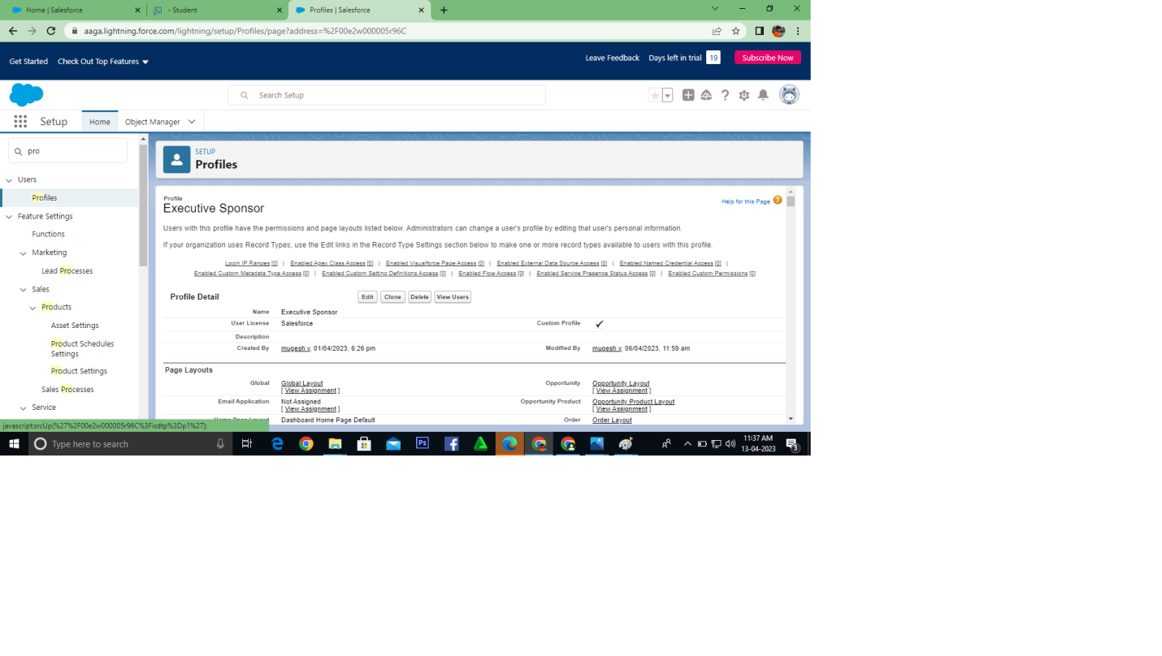

**New User**

1. A user is anyone who logs in to Salesforce. Users are employees at your company, such as sales reps, managers, and IT specialists, who need access to the company's records.

2. Every user in Salesforce has a user account. The user account identifies the user, and the user account settings determine what features and records the user can access.

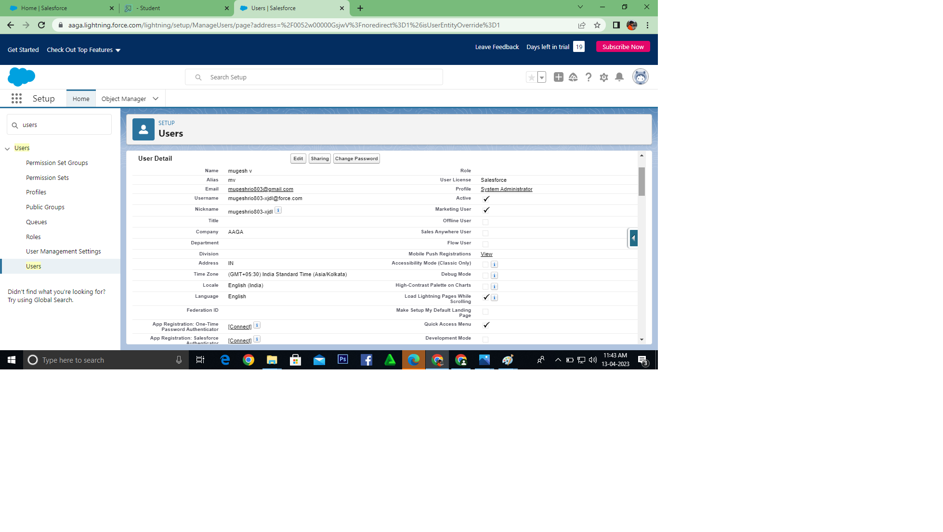

1. **Trailhead profile public URL**

**Team lead-** [**https://trailblazer.me/id/neethi03**](https://trailblazer.me/id/neethi03)

**Team Member 1-** [**https://trailblazer.me/id/mmurugan43**](https://trailblazer.me/id/mmurugan43)

**Team Member 2-** [**https://trailblazer.me/id/nk0312**](https://trailblazer.me/id/nk0312)

**Team Member 3-** [**https://trailblazer.me/id/murio5**](https://trailblazer.me/id/murio5)

1. **ADVANTAGES & DISADVANTAGES**

**ADVANTAGES:**

* Firstly, there is little to no risk when using Salesforce. Due to its low acquiring costs and low-risk management as an organization tool, there is very little to lose and a lot to benefit from.
* The database that Salesforce uses is also helpful in digitizing and organizing company sale records. Thus, improving the overall organization of a company.
* Salesforce and good customer service comes hand in hand.  It allows customization of profiles for individual customers as well as quick, organized access to individual records
* There is also no need to purchase software and hardware systems to help maintain and keep the application running.  Therefore, unlike most software, Salesforce requires no capital investment.
* The integrated solutions allow users to work more efficiently and increase the value of each part of the customer life cycle.  Moreover, Saleforce analytics and its reporting function gives its users the ability to expand their campaign capacity.  As a result, overall productivity can be increased and profit can be maximized.
* Since Salesforce is an application and no software is required, there is no need for constant updates as Salesforce will update automatically.

**DISADVANTAGES:**

* At times, there can be too much customization and the interface can be filled with cumbersome and tedious tools which can be seen as repetitive or distracting.
* Some users face difficulties in the transition between transactions.  Some have to go through multiple screens to process transactions.



* Salesforce has its own maintenance schedule since runs on its own cloud server.  As a result, there are times that the application will not be accessible.
* Users can also lose a personal touch as in the process of automation
* Salesforce contains barriers to adoption.  This means that even though Salesforce is cheap, the cost to integrate the application and redesigning their IT to incorporate it into a company is not the same as the cost of acquiring Salesforce. It is possible that the cost of integrating it can exceed the costs of the software itself.

1. **APPLICATIONS**

* It is a collection of tabs that work together as a single unit to give functionality.
* [Salesforce](https://intellipaat.com/blog/what-is-salesforce/) gives standard apps such as [Sales Cloud](https://intellipaat.com/blog/salesforce-sales-cloud/), Call Center, [**Salesforce Marketing Cloud**](https://intellipaat.com/blog/tutorial/salesforce-tutorial/salesforce-marketing-cloud-tutorial/), and Community.
* In Salesforce, you can customize an existing app to match the method to construct novel apps by assembling standard and custom tabs.
* Salesforce applications are of two types; one is the custom app and the other is the Service Cloud Console.

**Project Report Template**

1. **CONCLUSION**

Salesforce has been growing tremendously its employees, customers, offices throughoutthe world by providing innovative and best ideas/solutions to solve present generation businessproblems.

1. **FUTURE SCOP**

The project has a very vast scope in future. The project can be implemented on intranet in future. Project can be updated in near future as and when requirement for the same arises, as it is very flexible in terms of expansion. With the proposed software of database Space Manager ready and fully functional the client is now able to manage and hence run the entire work in a much better, accurate and error free manner. The following are the future scope for the project.

➢ Discontinue of particular student eliminate potential attendance.

➢ Bar code Reader based attendance system

➢ Individual Attendance system with photo using Student login